IDEATION PHASE
Brainstorm & Idea Prioritization
AI WEATHERWISE API
AI-Augmented Backend Development
Date | October 2026
Team ID | SWTID-2026-6651
Project Name | AI WeatherWise API
Maximum Marks | 4 Marks

Team Leader: DEEPIKA.N | Team Members: SIVA.M, VEERASEKAR.S, SHYAMKUMAR.A
PROJECT CONTEXT
AI WeatherWise is a RESTful backend platform built with Node.js and Express.js. It uses MongoDB/Mongoose for data persistence, integrates live weather information, and uses Google Gemini AI to provide natural-language weather summaries and personalized recommendations.

STEP 1: TEAM GATHERING, COLLABORATION & PROBLEM STATEMENT

Team & User Scenario
- Team leader: Deepika.N.
- Team members: Siva.M, Veerasekar.S and Shyamkumar.A.
- Scenario user: Alex, a travel enthusiast who visits different cities and needs quick access to local weather information.
- The team focused on a backend solution that can collect weather data, manage favorite locations, and turn raw weather metrics into understandable AI-driven guidance.

Selected Problem Statement
How might we build a secure backend service that lets users track favorite cities, obtain current weather information, and receive easy-to-understand AI summaries and activity/clothing recommendations?
- Users may find it difficult to track and manage multiple favorite weather locations.
- Raw weather metrics do not directly provide personalized activity or clothing suggestions.
- Users need natural-language summaries instead of only numerical weather values.
- A secure system is needed to store and synchronize user preferences across devices.
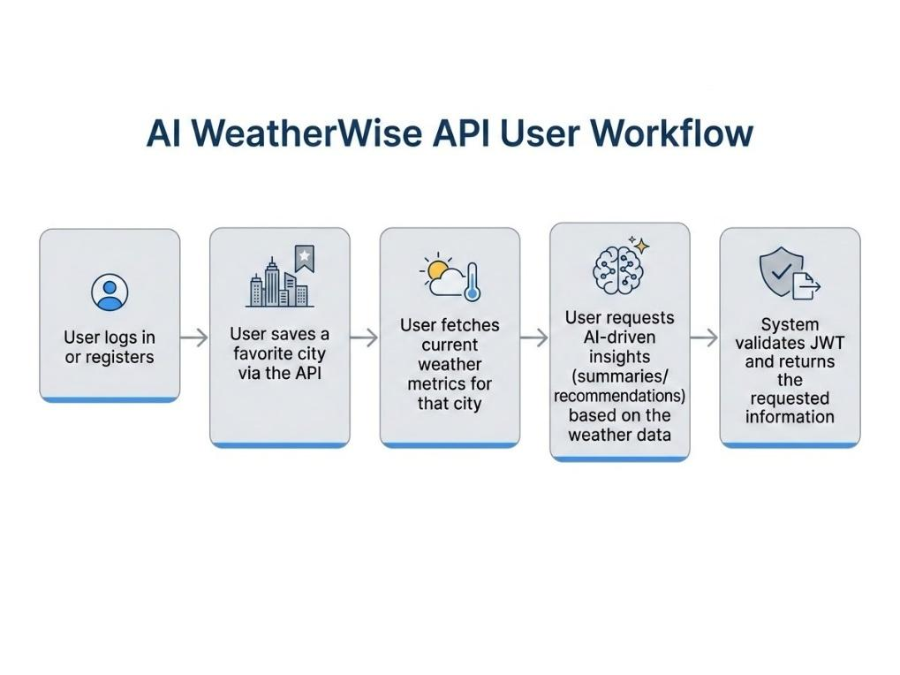
Figure 1. AI WeatherWise API user workflow from the project documentation.

STEP 2: BRAINSTORM, IDEA LISTING & GROUPING

Brainstormed Ideas
Idea | Purpose | Group
Real-time Weather Retrieval | Connect the backend to a weather service and return current weather metrics for a selected city. | Core Weather
Favorite Locations | Allow authenticated users to add, view, update and delete favorite locations. | User Management
AI Weather Summary | Convert live weather data into a simple natural-language explanation using Gemini AI. | AI Feature
Personalized Recommendations | Generate activity and clothing recommendations from current temperature and conditions. | AI Feature
Secure Authentication | Use JWT authentication and bcrypt password hashing to protect user resources. | Security
Fallback Mode | Keep core API functionality available when external API keys/services are unavailable. | Reliability
Centralized Error Handling | Provide consistent error responses and sanitize request inputs. | Security/Reliability
API Testing | Use Postman or Thunder Client to verify API routes and responses. | Testing

Idea Grouping
- Weather & Data: real-time weather retrieval and favorite-location management.
- AI & Personalization: weather summaries and personalized recommendations.
- Security & Reliability: JWT, bcrypt, fallback mode, sanitization and centralized error handling.
- Testing & Integration: API testing with Postman/Thunder Client and service integration checks.
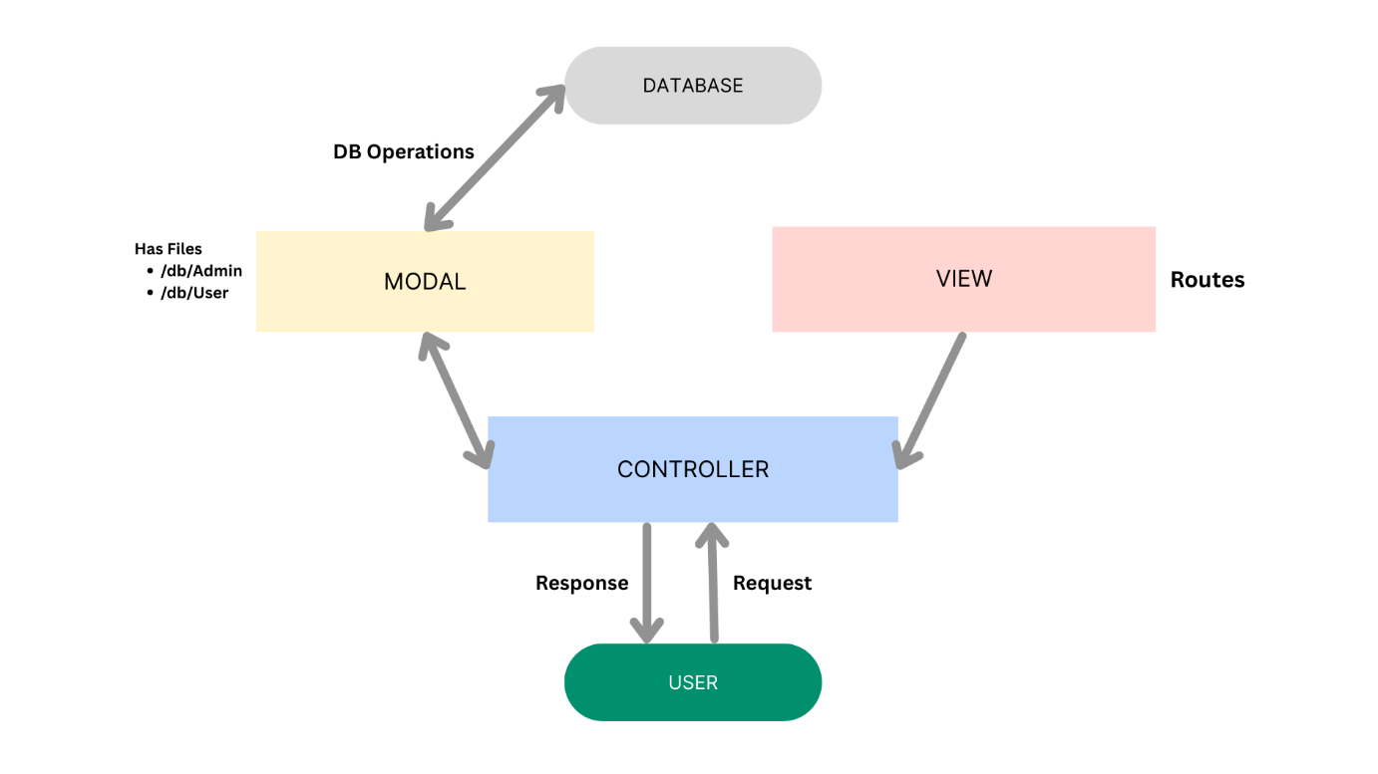
Figure 2. MVC architecture used by the AI WeatherWise backend.
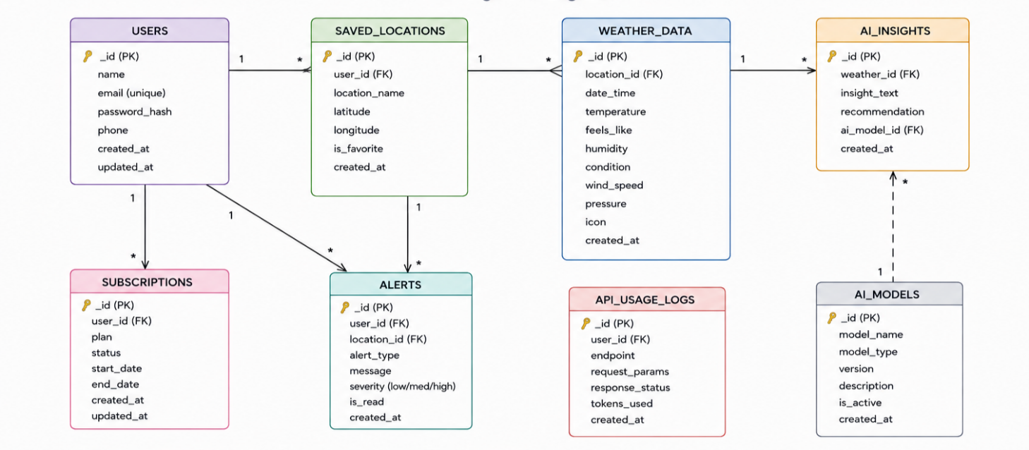
Figure 3. Data/entity structure used for users and related locations.

STEP 3: IDEA PRIORITIZATION

Prioritization Criteria
- User value: Does the idea directly solve the identified weather-tracking problem?
- Technical feasibility: Can the idea be implemented with the selected backend technologies?
- Security/reliability: Does it improve safe and dependable API operation?
- Integration value: Does it connect effectively with the weather, database or AI services?
Priority | Selected Idea | Reason | Implementation Area
High | Real-time Weather Retrieval | Core requirement for current weather information. | Weather API + Express
High | AI Weather Summary | Directly addresses the need for understandable weather information. | Gemini AI
High | Personalized Recommendations | Provides actionable activity/clothing guidance. | Gemini AI + weather data
High | Favorite Locations | Solves multi-city tracking and preference management. | MongoDB + Mongoose
High | Secure Authentication | Protects user-specific resources and preferences. | JWT + bcrypt
Medium | Fallback Mode | Improves resilience when external services/keys are unavailable. | Backend service layer
Medium | Error Handling & Sanitization | Improves API consistency and input safety. | Middleware
Medium | API Testing | Helps verify routes and responses during development. | Postman / Thunder Client

Final Concept Selected
AI WeatherWise API combines the prioritized ideas into one backend workflow: a user registers/logs in, saves a favorite city, fetches current weather, requests AI-generated insights, and receives the requested information through secure REST APIs.

Project Implementation Evidence

Figure 4. Backend server configuration from the project documentation.
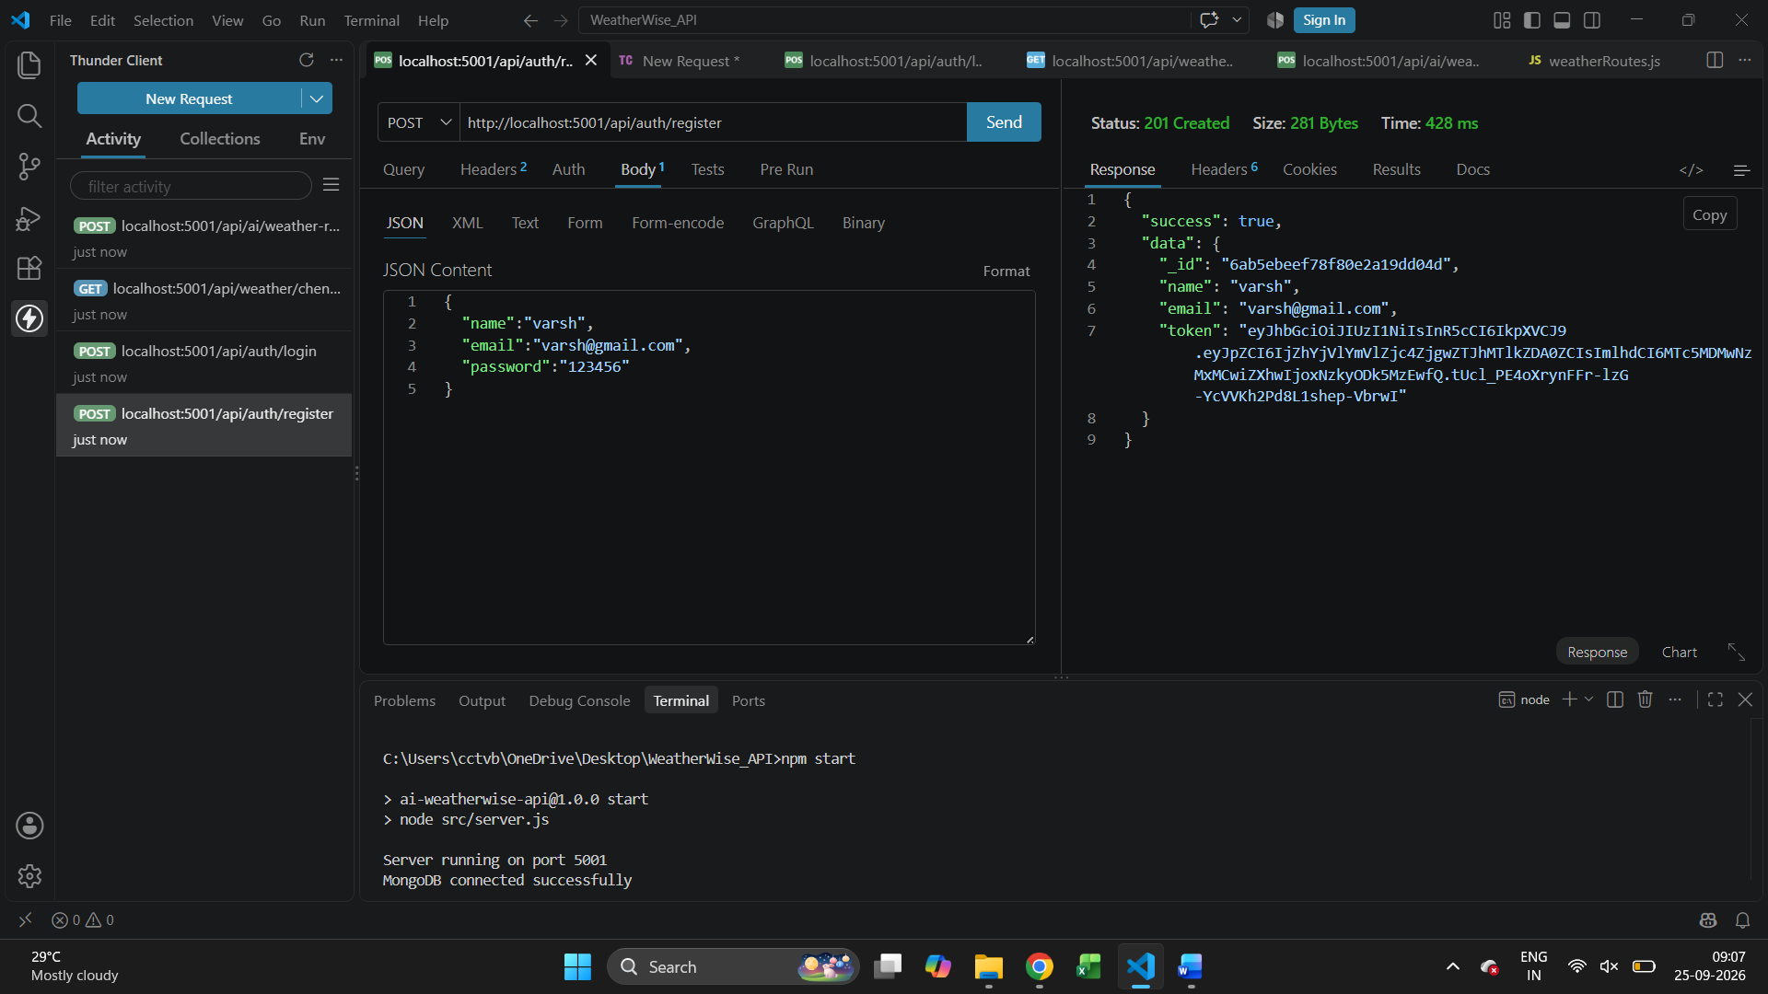

Expected Outcome
The prioritized concept provides a centralized weather backend that reduces the effort of interpreting raw weather metrics, supports favorite locations, and provides context-aware AI advice while maintaining authentication, database persistence and API reliability.

